Beach-Dune Ecosystem
At the beginning of the summer when you go to the beach you often hear someone saying, “This year there is not a lot of sand on the beach!”
Sand does not disappear, it moves from one place to another by wave and wind action. Waves bring sand to the shore and then, it is transported inland by the wind. Obstacles, such as a sand fence or vegetation, reduce wind speed, causing sand to accumulate. As sand accumulates, plants adapted to the beach environment emerge, stabilizing the surface and promoting further dune formation. Vegetation is critical to dune formation and stabilization, without vegetation, blowing sand will migrate.
Near-shore sandbars, beach and dunes make up what is called the beach-dune system
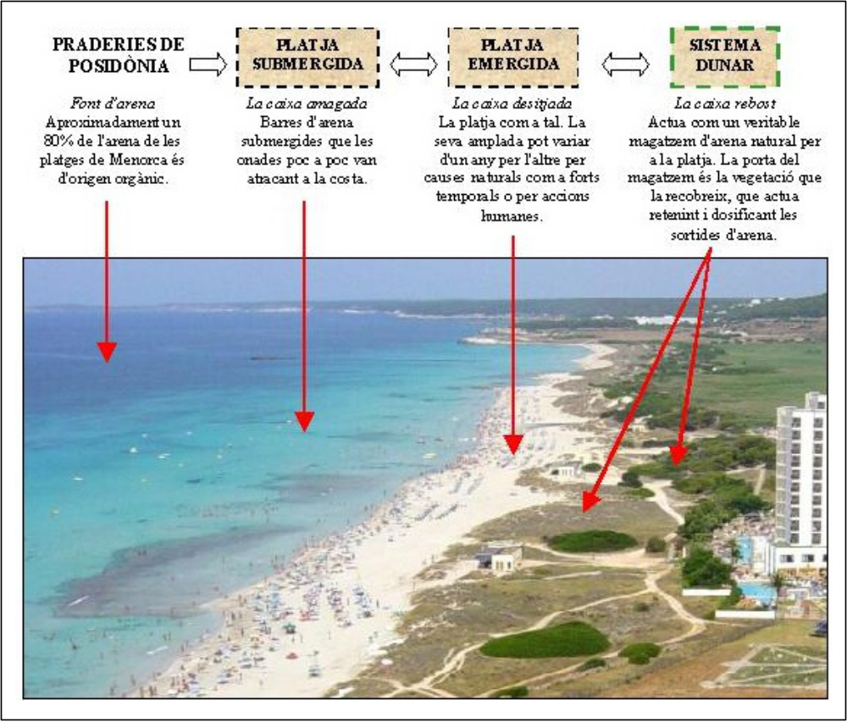
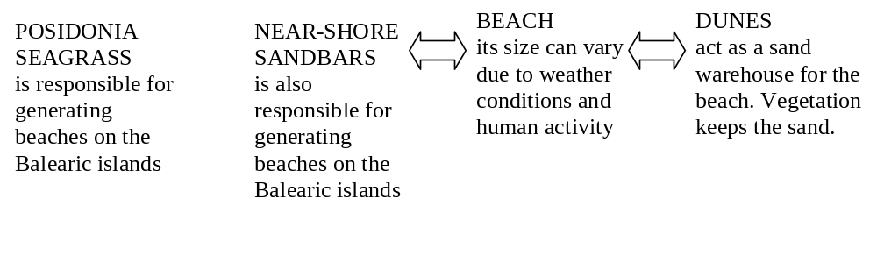

During storms, sand erodes from the beach-dune system and redeposits as shallow sandbars offshore. In a stable beach-dune system, there is a natural balance between the sand that enters the system and the one that leaves it.
Human activity can upset this natural balance, for example:
- Destruction of posidonia seagrass due to sea pollution or changes in the sea currents dynamics (due to man-made seaports).
- Aggressive beach cleaning systems which change the shape of beaches and dunes.
- Opening of paths on the dunes which damage the vegetation that holds the sand.
- Promenades or other types of infrastructures behind the beach which can destroy the dunes completely.

After having seen the beaches of Cala Mesquida and Cala Agulla answer the following questions
- Which parts of the beach-dune system have you observed?

- What does this tell you about the state of the beach is in?

- State the human activities that have an impact on this system.

- Which are the type of plants you can most frequently observe: grasses, shrubs/bushes or trees? Actually, these plant types are linked to different areas in the dunes. Match the plant type to the dune it belongs to:
Grasses | Area closest to the shore
Bushes/shrubs | Mid area
Trees | Inland area

- What differences can you observe between both beaches?

Seashore Plants of the Balearic Islands
- All these are species you might find in sandy beaches and dunes. Look at the pictures carefully and then browse the area where you are trying to find as many as you can.
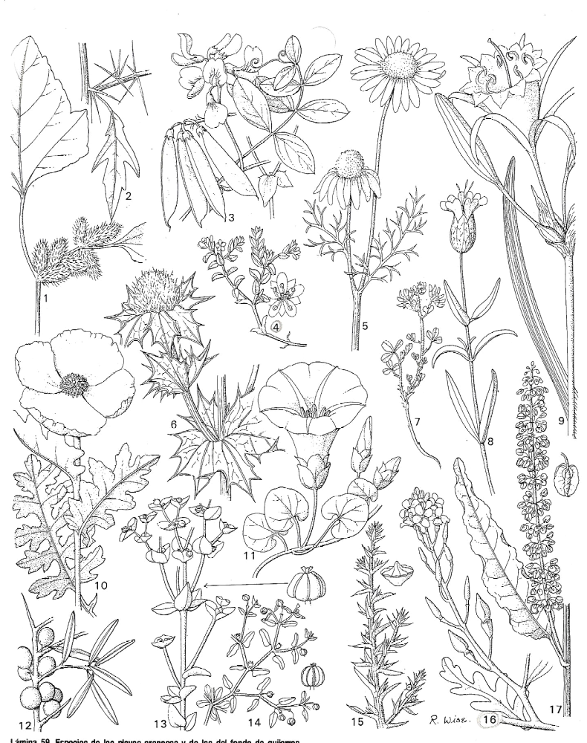

- Can you identify any of them? Which?

- Have you found any plant which is not in the diagram? Draw a rough sketch of it. How would you be able to find out which species it is?

- Now make sure you find number 6, number 9 and number 16. These three plants are really typical of Majorcan beaches and dunes. Their names are Sea holly (Eryngium maritimum), Sea daffodil (Pancratium maritimum) and Sea rocket (Cakile maritima). How many can you count of each?

Plant | Number
Sea holly
Sea daffodil
Sea rocket

The roots of the sea daffodil are specially long and its fruits have a spongy like tissue. Why do you think this plant has these two adaptations (Circle the two correct answers)?
To make the seeds float
To make the seeds be carried by the wind
So that the roots can search for moisture
So that the roots can reach the sea

- Now look at the following figure, it is the Rock samphire. The locals call it ‘Fonoll marí’. Where do you think it lives?
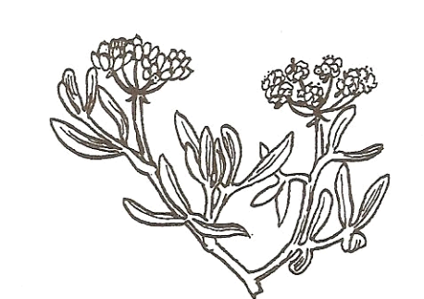
Try to find some Crithnum maritimum that is its Latin name! How many did you find?

- Have you ever heard about Posidonia oceanica?
Try to find some brown stringy balls near the shore. These are the left overs of Posidonia. Open one of the balls and see what is inside.
What do you think Posidonia is?

Actually Posidonia is a genus of flowering plants. THEY ARE NOT ALGAE!!! It contains two to nine species of marine plants ("seagrass"), found in the seas of the Mediterranean and around the south coast of Australia. In the case of Posidonia oceanica it is an endemic plant to the Mediterranean Sea, where it forms undersea meadows.
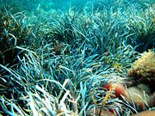
This image shows one of these meadows.
In the winter this plant sheds its leaves which are swept out to the beaches. The remains of these leaves make the brown balls you have found!!!

